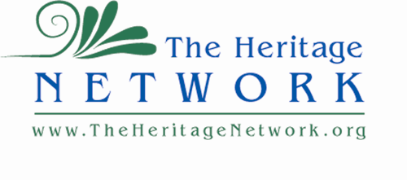

City of Colville

Vinson Fund

170 South Oak

Colville, WA 99114

RE: 200th Anniversary of the Establishment of Hudson’s Bay Fort Colvile \*

Respected Vinson Fund Advisors:

This Vinson Fund Application requires some explanation because the events that will be most affected will be held in 2025. This early application is warranted by our intention to feature a 30-foot-long Columbia Boat in the Spring and Summer, 2025, presentations of this 3-part event schedule. One of the main functions of this Hudson’s Bay Fort was the production of Columbia Boats. These unique craft were developed by famous explorer and cartographer, David Thompson, in the winter of 1810-1811 at Boat Encampment near current day Revelstoke BC. A critical innovation was lapstrake construction using cedar planks. Because of the abundance of cedar and its position on the banks of the Columbia, Hudson’s Bay commissioned the construction of hundreds of these boats at Fort Colvile. With capacity for several tons of supplies, a weight light enough to portage around rapids, and their relative ease of repair, they continued to be the main transportation vehicle of the fur trade for 40 years.

The Kettle Falls-Colville area continues to be a center of quality boat construction and cedar supply to this day. To bring this tradition to light, the Heritage Network wants to have a full-sized replica built of this historic craft. We have secured plans through fur trade historian Tom Holloway and found an experienced canoe builder, John Zinser, who can build this craft with help and advice from Native canoe expert, Sean Brigman, a professor at Gonzaga University.

This application is being submitted early in 2024 to allow time to secure the materials that Zinser requires and have the boat constructed in time for the Bicentennial.

In addition to the usual support documents for a Vinson Grant request, also attached are plans for the boat, a spreadsheet of anticipated costs from John Zinser, historical articles about the boat itself and a list of experienced historical advisors who have been guiding this project as it has developed over the past two years.

Because this is an advanced application, documentation for all the anticipated costs for publicity, contracts, materials, travel etc. are not available. A list of other granting agencies and a schedule of applications for them is included along with anticipated funds to be raised directly by the Heritage Network. This request is limited to funds to purchase materials for the boat. Local suppliers, Columbia Cedar and Webley Lumber have been contacted and are working with us on logistics. We value an early grant from the Vinson Fund as not only a first step on a long road, but as an opportunity to demonstrate and publicize community support; to help raise community awareness of this history; and to encourage partnership with other granting agencies.

A compilation of articles about our cultural ties to Hudson’s Bay is included with this application. Further inquiries and suggestions are welcome.

Sincerely,

Joseph A. Barreca, President of The Heritage Network